“Intentionally Building Biblical Men”
The expressed goal of the Men’s Ministry Team is to be about the business of intentionally building biblical men.
To that end, the aim of each investment, each event, each devotional, is to give practical, ‘meat and potatoes’ pieces of biblical truth.
We start with the topic of Strategic Prayer.

What is Prayer?
We start in Matthew 6, with Jesus teaching his disciples how to pray. Where better to learn about prayer than from Jesus?
Matthew 6 / New King James Version
9 In this manner, therefore, pray:
Our Father in heaven,
Hallowed be Your name.
10 Your kingdom come.
Your will be done
On earth as it is in heaven.
11 Give us this day our daily bread.
12 And forgive us our debts,
As we forgive our debtors.
13 And do not lead us into temptation,
But deliver us from the evil one.
For Yours is the kingdom and the power and the glory forever. Amen.
Though often termed “The Lord’s Prayer” this passage might be more accurately call “The Disciple’s Prayer”, as Jesus is teaching his disciples how to pray and clarifying what prayer is.
One commentator (Barclay) made the following observations:
“We must note the order of the petitions in the Lord's Prayer. The first three petitions have to do with God and with the glory of God; the second three petitions have to do with our needs and our necessities. That is to say, God is first given his supreme place, and then, and only then, we turn to ourselves and our needs and desires. It is only when God is given his proper place that all other things fall into their proper places. Prayer must never be an attempt to bend the will of God to our desires; prayer ought always to be an attempt to submit our wills to the will of God.” (emphasis mine) [Barclay, William, 1975, “THE GOSPEL OF MATTHEW”, Revised Edition, The Westminster Press]

Look again at that last line. We must recall that God is supreme, that his glory is primary. We pray not to gain our desires, rather to submit our wills to that of supreme God.
We can also take a lesson from the later part of the prayer. We also see a parallelism in the last three petitions, pointing to the Triune God-head, the whole of God:
“…give us this day our daily bread…”
Bread/maintenance of life/today/this day
Alludes to the Father, who is Creator and Sustainer

“…forgive us our debts…”
Forgiveness/the past/where we have been
Alludes to Jesus the Son of God and His forgiveness

“…lead us not into temptation…”
The future/what lies ahead
Alludes to the Holy Spirit, sent as our comforter, helper, guide
Again Barclay comments:
“In the Lord's Prayer Jesus teaches us to bring the whole of life to the whole of God, and to bring the whole of God to the whole of life.”
We see in the Lord’s Prayer the supremacy of God, the submission of our wills to His, and all-encompassing nature of a prayer-soaked relationship with our Lord.
So why does prayer feel so unnatural sometimes? Why is prayer often hard? Is it really important?

Why Do We Pray?
We live in a broken world that needs Jesus. We should fee that burden every day. One of the books on my shelf states a call to prayer like this:
“The demand of our day is very distinct and urgent. It is for a spiritual force, which will enable the Christian warrior effectively to antagonize adverse powers, as they seek, at each point of conflict, to hinder through him the accomplishment of the Divine plan of redemption.
What can supply that demand, in the greatest possible measure, is prayer. To know how to use all that is implied in that is to bring on to the battlefield an irrepressible power.
Much has been written on this subject, but the great text-book of prayer is the Word of God. It shows me at prayer in different surroundings, under varied conditions, faced by strong difficulties, yet triumphant.
Think of Abraham pleading for the cities of the plain, (Genesis xviii); of Moses at Rephidim (Ex. xvii.); of Joshua before Ai (Josh vii.); of Daniel in Babylon (Dan. ix); of the disciples in Jerusalem (Acts iv.); of Paul in Rome (Eph. Iii).
Demands were made upon their spirit, their faith, their courage, which drove them to God.
Need created within them the prayer sense, which could find rest only at the throne of God. Revealed to them by the Spirit of God was the fact of peril. Burned into them, this feeling of danger forced our fo their beings…the spirit of prayer, and its answers were great and far reaching.”
The Scriptures show men in prayer for times of deep need. And out of prayer, God shows himself great and his answers to that prayer shine through history. The book follows it up with this:
“That we are up against altogether new conditions in spiritual concerns is apparent to all.
Prayer is the God-given means of waging war against those powers of evil which are pressing in upon the Church of God to silence her witness, defeat her aims, and hinder her translation; and it is the consciousness of need in that struggle which constitutes the call to prayer.”
This sounds a lot like what we hear today, day in and day out, of a broken world, with the Church under attach. But this was written by Rev. Gordon Watt (“The Strategic Power of Prayer”) in 1922; 100 years ago! Nothing is new under the sun; God is still supreme. The situation is indeed dark, the foe is real; but the devil is a conquered foe. The call to prayer reminds us of the hopefulness of the hour.
We bear witness to the fact and force of Calvary.
We retain the vision of the coming Kingdom of God.
We seek revival to a spirit of aggressive prayer.

How To Build A Life of Prayer
The first things first: If you have not accepted God’s free gift of forgiveness of sins (repenting of your sin , asking Jesus to cleans you and to be supreme in your life), then you are not a disciple of Jesus. Your sin still separates you from God, and your prayer will be ineffective. That relationship must be taken care of first. [Simple Good News - The Harbor Church]
If you are a disciple of Jesus, you have a Helper (the Holy Spirit) from God.
So what do you do?
Start. Anywhere. Get moving. It’s the classic question of “When is the best time to start exercising or investing?”, where the answer is inevitable “10 years ago!”. But the second best time is TODAY.
In addition, it is easier to change the direction of an object in motion. Get some momentum and adjust as you go. Think of if this way, sort of as a feedback loop:
Plan: make a plan (simple, achievable, with benchmarks)
Act: do the plan; gain momentum, build good habits
Grow/Develop: Get better by doing; learn what works/doesn’t
Reflect: revisit the plan, see if you hit the benchmarks, see where you are at from the growth phase, and reset the Plan, thus effectively jumping back into “Act” phase.
Repeat the cycle
The rub: I fail at prayer. If I tell a friend I will pray for them, I do. But at the same time, when I sit down to pray or try to pray while driving/exercising, my brain turns into a blank canvas. I need tools to help me, because without them I get lost in the “execution” phase. So, here are a few tools that I have found useful.

Prayer Resources (List)
Primary: The Word of God (the Bible)
Prayer in God’s word is central! So many areas deal with prayer.
One idea: Praying through Psalms is a fantastic exercise. Try reading a Psalm each day that correlates to the day of the month (i.e. on the 5th of the month, read Psalm, 5, or Psalm 35, Psalm 65, Psalm 95, Psalm 125; on the 6th of the month, read Psalm 6, Psalm 36, etc.)
You can mark notes in your bible, in a notebook, on an App, or even a dedicated scripture notebook (One resource that appeals to me and which I use in other contexts: ESV Scripture Journal: Psalms: 9781433546495 - Christianbook.com)

Secondary: All other books/etc.
Puritan prayers to jump start your thinking:
Men and women just like you and I have been seeking God’s heart and praying for millennia; this compilation is a helpful ‘jump start’ for my prayers or even as a prayer I can pray when I am empty
Valley of Vision (Bonded Leather): Arthur Bennett: 9780851518213: Amazon.com: Books
A list of how to pray for your wife:
I have a notebook that I use for journaling, for sermon notes, for my everyday thoughts. In it I have a page dedicated to a copy of “Lifting My Wife in Prayer”. This resource lists many prayer points that guide a comprehensive, Scripture based prayer for your wife.
Lifting_My_Wife_in_Prayer_tx21DmcX4CY.pdf (familylife.com)
A topical structure to guide prayer time: When my mind goes blank, I often fall back to the acronym ACTS.
Adoration (praising God, placing His supremacy at the fore front of my call to Him)
Confession (He is faithful and just to forgive and desires a broken and contrite heart)
Thanksgiving (thanking God for who He is and what He has done)
Supplication (bringing requests to Him, for me or others)
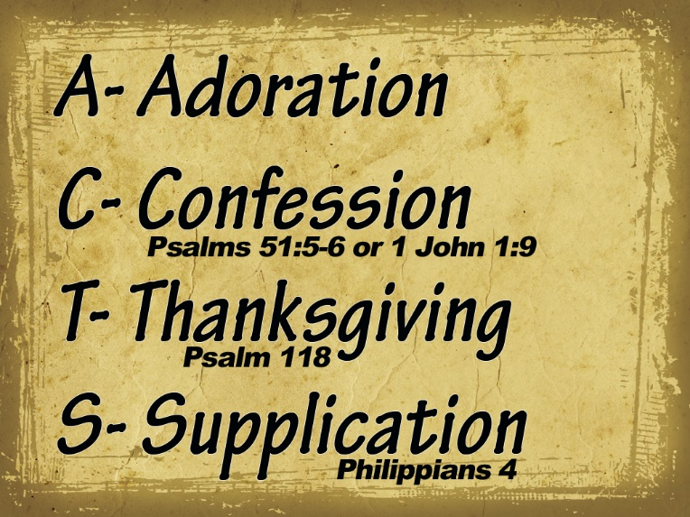
Graphic Source: https://www.nealbenson.com/2015/10/the-acts-mode-of-prayer.html
One final resource for keeping prayer on our hearts and minds is found on our church website under “Papers & Articles”.
“When it comes to prayer, there’s either God’s way to do it or man’s way to do it. As you could have guessed, God’s way is always the best.” Economy of Prayer - The Harbor Church

