“Intentionally Building Biblical Men”

Prayer Resources (List)
Primary: The Word of God (the Bible)
Prayer in God’s word is central! So many areas deal with prayer.
One idea: Praying through Psalms is a fantastic exercise. Try reading a Psalm each day that correlates to the day of the month (i.e. on the 5th of the month, read Psalm, 5, or Psalm 35, Psalm 65, Psalm 95, Psalm 125; on the 6th of the month, read Psalm 6, Psalm 36, etc.)
You can mark notes in your bible, in a notebook, on an App, or even a dedicated scripture notebook (One resource that appeals to me and which I use in other contexts: ESV Scripture Journal: Psalms: 9781433546495 - Christianbook.com)

Secondary: All other books/etc.
Puritan prayers to jump start your thinking:
Men and women just like you and I have been seeking God’s heart and praying for millennia; this compilation is a helpful ‘jump start’ for my prayers or even as a prayer I can pray when I am empty
Valley of Vision (Bonded Leather): Arthur Bennett: 9780851518213: Amazon.com: Books
A list of how to pray for your wife:
I have a notebook that I use for journaling, for sermon notes, for my everyday thoughts. In it I have a page dedicated to a copy of “Lifting My Wife in Prayer”. This resource lists many prayer points that guide a comprehensive, Scripture based prayer for your wife.
Lifting_My_Wife_in_Prayer_tx21DmcX4CY.pdf (familylife.com)
A topical structure to guide prayer time: When my mind goes blank, I often fall back to the acronym ACTS.
Adoration (praising God, placing His supremacy at the fore front of my call to Him)
Confession (He is faithful and just to forgive and desires a broken and contrite heart)
Thanksgiving (thanking God for who He is and what He has done)
Supplication (bringing requests to Him, for me or others)
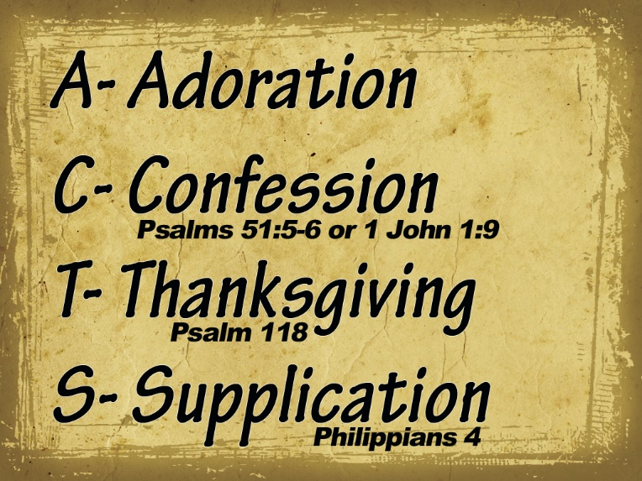
Graphic Source: https://www.nealbenson.com/2015/10/the-acts-mode-of-prayer.html
One final resource for keeping prayer on our hearts and minds is found on our church website under “Papers & Articles”.
“When it comes to prayer, there’s either God’s way to do it or man’s way to do it. As you could have guessed, God’s way is always the best.” Economy of Prayer - The Harbor Church

